

**TRIBHUVAN UNIVERSITY**

**Faculty of Humanities and Social Sciences**

**“Canteen Management System”**

**A PROJECT REPORT**

**Submitted to**

**Department of Computer application**

**Asian College of Higher Studies**

# In partial fulfillment of the requirement for the Bachelors in Computer Application

Submitted by

Binish Adhikari (22061010)

Under the supervision of

**Pranaya Nakarmi**



**TRIBHUVAN UNIVERSITY**

**Faculty of Humanities and Social Sciences**

**Asian College of Higher Studies**

**SUPERVISOR’S RECOMMENDATION**

It is my pleasure to recommend that a report on “**Canteen Management System**” has been prepared under my supervision by **Binish Adhikari** in partial fulfillment of the requirement of the degree of Bachelor in Computer Application (BCA). Their report is satisfactory to process for the future evaluation.

……………………………

Mr. Pranaya Nakarmi

Supervisor

Department of humanities

ACHS College



**Tribhuvan University**

**Faculty of Humanities and Social Sciences**

**Asian College of Higher Studies**

**LETTER OF APPROVAL**

The undesigned certify that he has read and recommended to the Department of humanities for acceptance of report entitled “**Canteen Management System**” submitted by **Binish Adhikari** in partial fulfillment for the degree of Bachelor in Computer Application (BCA), Department of humanities Tribhuvan University.

|  |  |
| --- | --- |
| **SIGNATURE of Supervisor** | **SIGNATURE of HOD/ Coordinator** |
| **SIGNATURE of Internal Examiner** | **SIGNATURE of External Examiner** |

# ACKNOWLEDGEMENT

I sincerely acknowledge with gratitude all the people’s assistance that made my study a success. My special thanks go to BCA Coordinator and my supervisor Mr. Pranaya Nakarmi whose guidance, constructive suggestions, and encouragement that greatly contributed to my completing this report.

I am thankful to TU for giving me this opportunity to broadening my theoretical knowledge and putting it into practical use.

## Your Sincerely

Binish Adhikari

# ABSTRACT

The Project “Canteen Management System” enables the end user to register online, read and select the food from menu and order food online by just selecting the food that the student want to have using web application. Simplification of orders, stock control boost, and speedy payment processing are the chief objectives of any canteen management system. This is to enable the provision of improved user experience through this service with personalized services and feedback options. Through automation of daily activities, it has reduced inefficiencies from workers and allowed them to work together as a team. It also provides reports that can help improve decision-making processes while ensuring data is secure. On top of this, the system is developed in such a way that it can be easily used by anyone who may want to use hence enhancing communication and growing with the canteen’s needs through smooth integration into other systems. Facilitates quick and accurate order placement, tracking, and fulfillment for students, staff, or employees. Maintains records of users, including login credentials, personal preferences, and order history, enhancing personalized service. Provides detailed reports and insights on sales.

Helpful to perform work and manage data.

Table of Contents

ACKNOWLEDGEMENT ................................................................................................ IV

ABSTRACT ....................................................................................................................... V

LISTS OF FIGURES ...................................................................................................... VIII

LISTS OF TABLES ......................................................................................................... IX

LIST OF ABBREVIATIONS ............................................................................................. X

CHAPTER 1: INTRODUCTION ...................................................................................... 11

1.1 Introduction.............................................................................................................. 11

1.2 Problem of statement ............................................................................................... 11

1.3 Objectives ................................................................................................................ 12

1.4 Scope and limitation ................................................................................................ 12

1.4.1 Scope: ............................................................................................................... 12

1.4.2 Limitations ........................................................................................................ 12

1.5 Report Organization ................................................................................................. 12

Chapter 2: Background Study and Literature Review ....................................................... 13

2.1 Background Study ................................................................................................... 13

2.2 Literature Review .................................................................................................... 13

Chapter 3: System Analysis and Design ............................................................................ 15

3.1 System Analysis ....................................................................................................... 15

3.1.1. Requirement Analysis ...................................................................................... 15

3.1.2 Feasibility Study ............................................................................................... 17

3.1.3. Data Modeling (ER-Diagram) ......................................................................... 19

3.1.4. Process Modeling (DFD) ................................................................................. 20

3.2. System Design ........................................................................................................ 21

3.2.1. Architectural Design ........................................................................................ 22

3.2.3. Interface Design (UI Interface / Interface Structure Diagrams) ...................... 23

Chapter 4: Implementation and Testing ............................................................................. 24

4.1. Implementation ....................................................................................................... 24

4.1.1. Tools Used (CASE tools, Programming languages, Database platforms) ....... 25

4.2 Implementation Details of Modules ........................................................................ 26

4.3 Testing ...................................................................................................................... 27

4.2.2. Test Cases for Unit Testing .............................................................................. 27

4.2.2. Test Cases for System Testing ......................................................................... 29

Chapter 5: Conclusion and Future Recommendations ...................................................... 30

5.1 Lesson Learn / Outcome .......................................................................................... 30

5.2 Conclusion ............................................................................................................... 30

5.3 Future Recommendations ........................................................................................ 30

Chapter 6 References: ........................................................................................................ 31

# LISTS OF FIGURES

Figure 3. 1 Use Case Diagram ........................................................................................... 16

Figure 3. 2 ER Diagram ..................................................................................................... 19

Figure 3. 3 Level 0DFD ..................................................................................................... 20

Figure 3. 4 Level1 DFD ..................................................................................................... 20

Figure 3. 5 Level 2DFD ..................................................................................................... 21

Figure 3. 6 System Architecture ......................................................................................... 22

Figure 3. 7 Database Schema ............................................................................................. 22

Figure 3. 8 Home-Page ...................................................................................................... 23 Figure 3. 9 Waterfall Model ............................................................................................... 24

# LISTS OF TABLES

Table 3. 1 Requirement for system .................................................................................... 15

Table 3. 2 Student requirement .......................................................................................... 16

Table 3. 3 Gantt Chart ........................................................................................................ 18

Table 4. 1 Unit Testing…………………………………………………………………...28

Table 4. 2 System Testing .................................................................................................. 29

# LIST OF ABBREVIATIONS

|  |  |
| --- | --- |
|  |  |
| CSS | Cascading Style sheets |
| DFD | Dataflow Diagram |
| ERD | Entity Relationship diagram |
| HTML | Hyper Text Markup Language |
| JS | JavaScript |
| PHP | Hypertext Preprocessor |
| SQL | Structured Query Language |

# CHAPTER 1: INTRODUCTION

## 1.1 Introduction

The canteen management system is one of the latest service most canteen is adopting to. Due to the great increase in the awareness of internet and the technologies associated with it, several opportunities are coming up on the web. Canteen Management System enables the end users to register online, view, select and order food online within the college premises. The results after selecting the food from the menu will directly appear in the screen of the Chef which is assigned as admin. By using this user-friendly web application, the work of the waiter is reduced and we can order food anytime. The benefit of this system is that if there is rush in the Canteen then there will be chances that the waiters will be unavailable to take orders so the students can directly order the food online by using this web application. The student will have to register and each of them will get username and password, by using which they can login into the system. This implies that the Student is the student of the college and student of the system. This system has a standard use of internet which allows students to order food as per their likes and the payment can be done on the delivery of the foods arrives.

**Time saving:** This system allows the students to order the foods without visiting the canteen.

Instead of going to canteen, the food can be ordered and delivered just by a few clicks.

**Free of use:** This system is free of cost to use to every student. The students will not have to pay any extra cost to register their account to order their foods.

## 1.2 Problem of statement

College canteen are storing their data in manual way. Many faculty students visit the canteen in their lunch break as per the college routine so they have limited time to eat and return to their respective classes. So, because of large number of students, they need the help of some features so they can maintain and store the records accurately. For staffs it is difficult to take orders, manage kitchen, and the counter simultaneously. They need an efficient software to maintain their day to day transactions, orders and also update records, food items, price etc. regularly. In the existing system, entering all the details are done manually, it is taking lots of time and also there are chances for mistakes.

Nowadays people don’t have much time to spend in canteen by just sitting there and queuing to get token and wait to get their order ready. Food can be ordered through the internet and payment can be made on delivery without going to the canteen. For this system, there will be a system administrator who will have the rights to enter the menu with current prevailing prices.

## 1.3 Objectives

* To order different food available according to the individual’s desire.
* To keep track of each orders and its details.
* To develop an appropriate, effective and efficient system to the students.

## 1.4 Scope and limitation

**1.4.1 Scope:**

In Nepal, the use of information technology is increasing day by day. For each and every task, the people are in the use if IT. The use of IT has also started to be used in the food sector of the countries, i.e. for restaurant, café and college canteens. The main task is to take the orders from the students through online website or web-based applications with cash on delivery system. Also, the students will be able to complain or give feedback if they have any problems with services.

### 1.4.2 Limitations

Like every other system, this system also has some limitations that does not include online payment system so that the students will not be able to make the payment directly through internet.

## 1.5 Report Organization

The report starts with the introduction of the canteen management system along with problem statement and objectives of the project. Here, we have introduced why our system is built and condition of manual systems which are not reliable. The chapter 2 analyses the existing system along with requirement as well as feasibility analysis of the system. The data modeling and process modeling technique are used to give the information about the system requirement. The Chapter 3 discusses about the system design along with the algorithm used. The system design can be database schema design, interface design and process design. The Chapter 4 explains about the tools that are used on our projects frontend, backend and purpose of it. The modules used are also explained. The testing is also explained in this part. The Chapter 5 discuss about the conclusion of how project is accomplished, its findings and many more. We also discuss about the recommendation for future enhancements of the project. In conclusion, this chapter overviews purpose of doing this project including its scopes and objectives.

# Chapter 2: Background Study and Literature Review

## 2.1 Background Study

Manual system involves billing and token system in the form of maintaining various files and manuals. Maintaining record of every transaction in the files manually when taking the order requires high man power and risky. There might be financial error and documentation is also difficult. There were many projects done under online food ordering facility our project canteen management system is also based on same theory.

The ordering system paper, tackled the similar project but it was not able to finish and confirm the order, in smart canteen system it was only possible for the student to place an order if they were registered with an application which wasn’t freely available.

So, our system is designed to provide student friendly interface with simple crude function. Admin can also view orders, feedbacks, update price and menu while student can simply place order and pay cash on delivery. Canteen management system is also freely available and easy to use.

## 2.2 Literature Review

We went through a lot of different research papers to understand all the previous work done on the project that we have undertaken. Manual system involves billing and token system in the form of maintaining various files and manuals. Maintaining record of every transaction in the files when taking the order is tedious process. To develop our project, we have understood these references;

Automated food ordering systems have proven to reduce wait times and minimize order processing errors, leading to improved operational efficiency and customer satisfaction. Several research papers have addressed aspects of this problem, each presenting unique solutions and facing specific challenges. For instance, one paper on an ordering system tackled a similar project but was unable to complete and confirm orders due to a lack of integrated payment systems [1]. Another study on menu automation successfully generated a real-time menu of available items but failed to enable order placement by students [2]. Similarly, research on order automation helped students decide on orders but could not process them to the merchant [3].

An Android-based ordering system was implemented successfully, but it only supported payment through cash on delivery, limiting its usability [4]. Another project involving RFID radio-controlled orders required smart cards and other physical hardware at both the student and merchant ends and was not web-based, reducing its accessibility [5]. The Smart Canteen paper indicated that students could place orders only if they were registered with an application that was not freely available, which limited its accessibility [6]. Lastly, the Online Menu Ordering paper described a portal based on an outdated framework, affecting its efficiency and usability [7].

The key benefits of canteen management systems include time efficiency, as automation saves time for both customers and staff, accuracy in order fulfillment by reducing errors, and convenience through remote ordering, which decreases canteen congestion [8]. However, user acceptance of these systems is influenced by perceived usefulness and ease of use, as posited by the Technology Acceptance Model (TAM) [9]. Intuitive interfaces and reliable performance are critical for user approval.

Despite these benefits, there are challenges and limitations. Technical difficulties can disrupt operations, user resistance to adopting new technologies can impede implementation, and ensuring data security is crucial to protect sensitive information [10, 11].

# Chapter 3: System Analysis and Design

## 3.1 System Analysis

The current system developed is the ‘Canteen Management System’. This system will allow the students to order the food online and the food ordered. For this system the Student will need to have the knowledge on how to use a website to order food online. The student will need to login or register in order to login for the student to order food online. The student will be able to cancel the order until the admin of the system has not marked the order as delivered to the Student. The student will be able to create a user id so that the student can complain about the services or give suggestion to the canteen. The admin of the system can add food items to the menu, adjust the price of the food available in the canteen and mark the food whether the added food items are available in the current time or not. The admin will also be able to view the order made by the student. So, the system designed in this project will enable students to go online and place the food order. This system would be the best solution for the crowd management and time saving.

### 3.1.1. Requirement Analysis

Requirements must be quantifiable, relevant and detailed. The main purpose of Requirement Analysis is to describe the functional and non-functional requirement of the project. All the requirements specified here are high priority and has been specified according to the requirement analysis. This document is intended to clarify the actual need of the system and verify its functionality with other member involved to design the system.

### Functional Requirements

Functional requirements show the operation and activities the system must be able to perform. Some of the functional requirement of the Canteen Management System are as follows:

Table 3. 1 Requirement for system

|  |  |
| --- | --- |
| S.no. | Requirements |
| 1. | System should show total cost according to food ordered. |
| 2. | System should show all the available foods along with cost. |
| 3. | System should allow the student to create their own account to order the foods. |
| 4. | System should allow admin to add foods and change their prices. |
| 5. | System should allow admin to view the orders. |
| 6. | System should have features of complain or feedback. |

Table 3. 2 Student requirement

|  |  |
| --- | --- |
| S.no. | Requirements |
| 1. | The system should allow the student to create their account |
| 2. | The system should allow the student to give their valid address, phone number and e-mail address. |
| 3. | The system should allow the student to enter the correct quantity of the food as they require. |

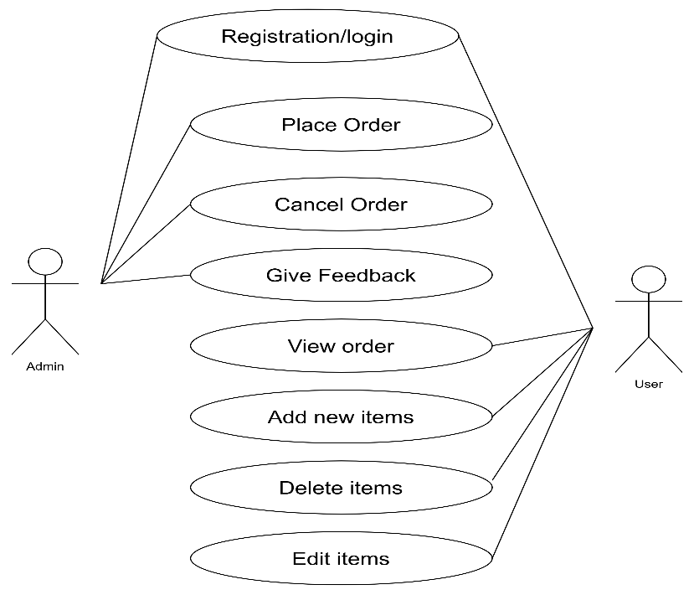

Figure 3. 1 Use Case Diagram

The figure above shows the use-case diagram of the Canteen Management System. The diagram is a representation of external factors such as Students and Admin that interact with the system. The Student use case can create their own account and login. They can place the order, cancel that order and also gives feedbacks if they require. The Admin use case can login, view the Student’s orders, add new food items, delete those food items and edit their prices to provide service to the students.

### Non-Functional Requirements

1. Student Friendly:

Student Friendly is self-explanatory. When something is user friendly then it is easy to access and work with it. Canteen Management system is user friendly. Person having basic knowledge and skills of computer can also easily use the web application. Canteen management system uses a simple design as well as simple language on the content to improve the user friendliness of the web application.

1. Easy Access:

Canteen management system is web application. It can be accessed anytime from anywhere with the help of internet connection.

**3.1.2 Feasibility Study**

### 1. Technical Feasibility

This sector measures the availability of technical resources and expertise. This project targets for desktop applications. This application is technically feasible as highly expert person is not required to use this application. Utilizing existing technology will lower the risk of our project. This application will be compatible in all browsers**.**

**Hardware requirements:**

* i7 processor or higher
* Monitor
* Internet connection

**Software requirements:**

* Windows 7 or higher
* MS Word
* Sublime Text
* Lucid chart
* My SQL
* Xampp server
* Visual Studio Code

### 2. Operational Feasibility

The operational feasibility is measures that how the proposed system will solve the existing problems and the study will the system work efficiently. If the system is not efficient, it will not produce the expected benefits. The system will have user friendly interface which will be much convenient as compared to the current manual process.

### 3. Economic Feasibility Study

This **CMS** project uses most of the free software’s so the cost could be manageable. We need a laptop and internet connection to run the system.

### 4. Schedule

This is one of the most important feasibility analyses as it helps an organization to estimate how much time the organization will take to complete the project and how much of it is on track to a given schedule.

Table 3. 3 Gantt Chart

|  |  |  |  |  |  |
| --- | --- | --- | --- | --- | --- |
| **Task Name** | **Project Schedule** | |  |  |  |
| **1-3 Weeks** | **4-5 Weeks** | **6-10 week** | **10-13** | **14 Weeks** |
| **Planning and**  **Analysis** |  |  |  |  |  |
| **Design and**  **Architecture** |  |  |  |  |  |
| **Implement** |  |  |  |  |  |
| **Deployment** |  |  |  |  |  |
| **Documentation** |  | |  |  |  |

#### 3.1.3. Data Modeling (ER-Diagram)

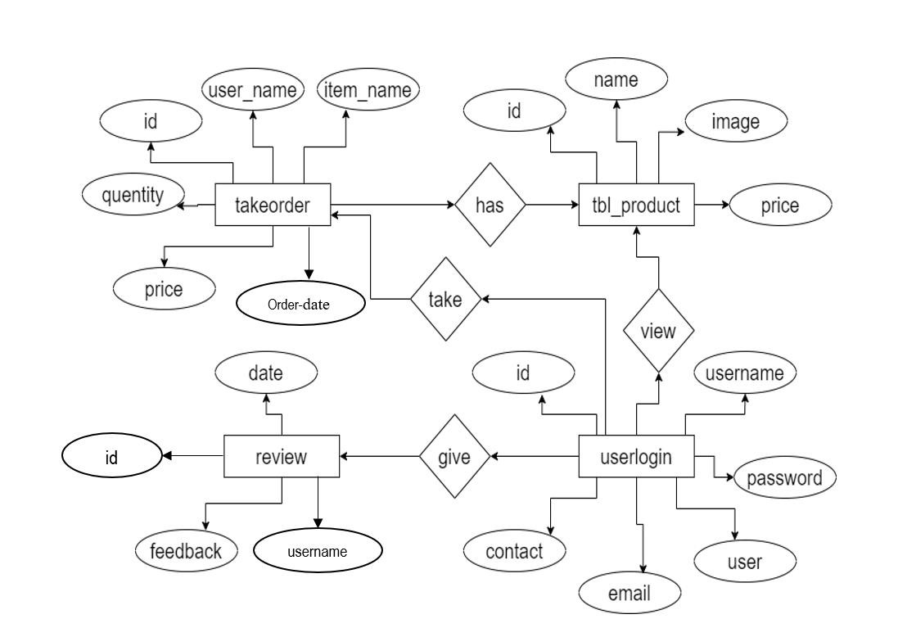

Figure 3. 2 ER Diagram

#### 3.1.4. Process Modeling (DFD)

1. **Level 0 DFD**

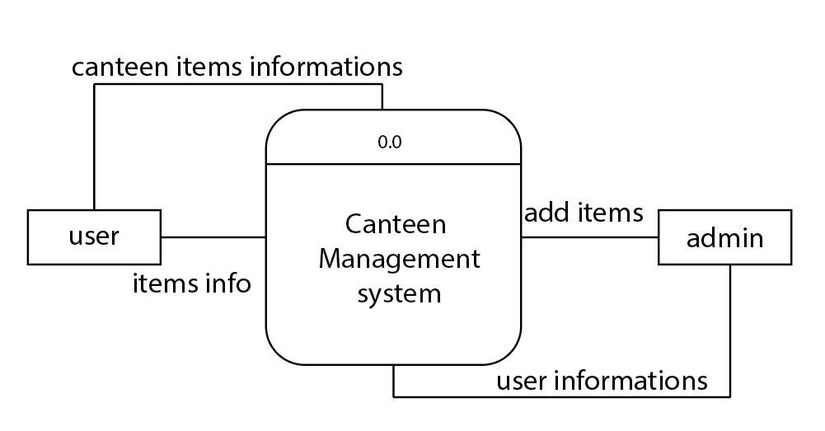

Figure 3. 3 Level 0DFD

1. **Level 1 DFD**

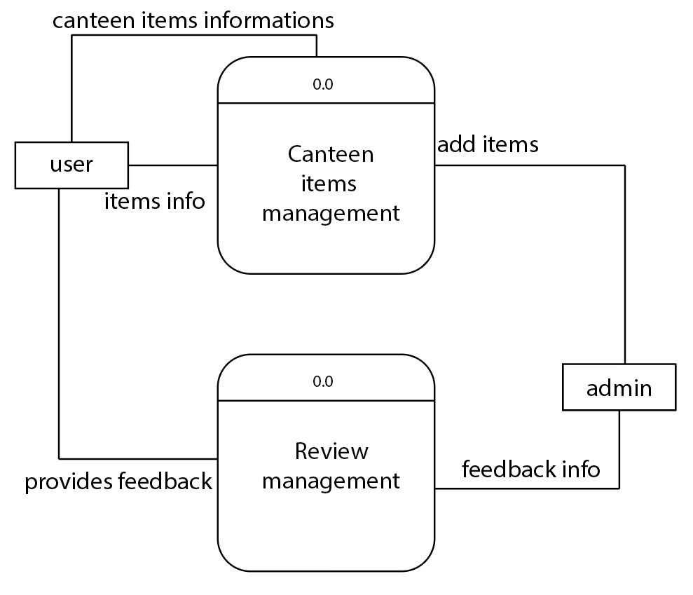

1.0

1.1

Figure 3. 4 Level1 DFD

### 3. Level 2 DFD

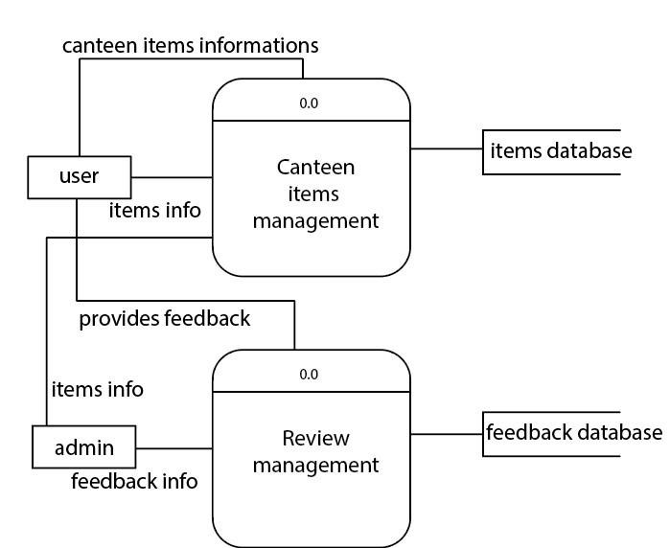

2.0

2.1

Figure 3. 5 Level 2DFD

## 3.2. System Design

System design is a process that overlaps significantly with the requirements development process. It involves establishing the overall architecture of the system, identifying the different system components and understanding the relationships between them.

(Sommerville, 2004)

Several diagrams were created in the design phase of the project such as system architecture, database schema diagram, E-R diagram, interface design and context diagram for the development process.

### 3.2.1. Architectural Design

The main focus of the canteen food system is to order the foods online by every Student of the organization. With the wide range of foods included, the students can decide on which food they want to choose.

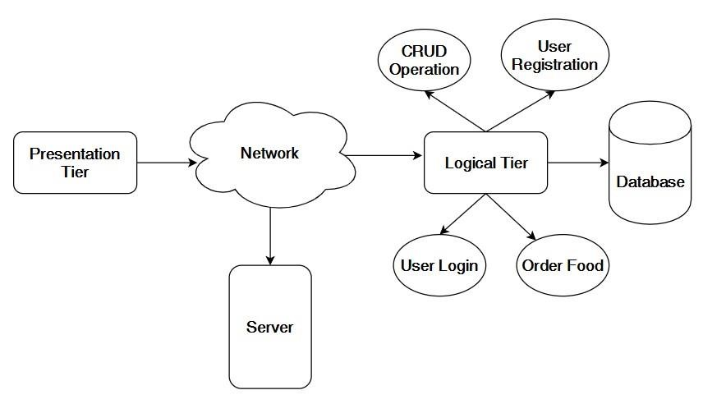

Figure 3. 6 System Architecture

3.2.2. Database Schema Design

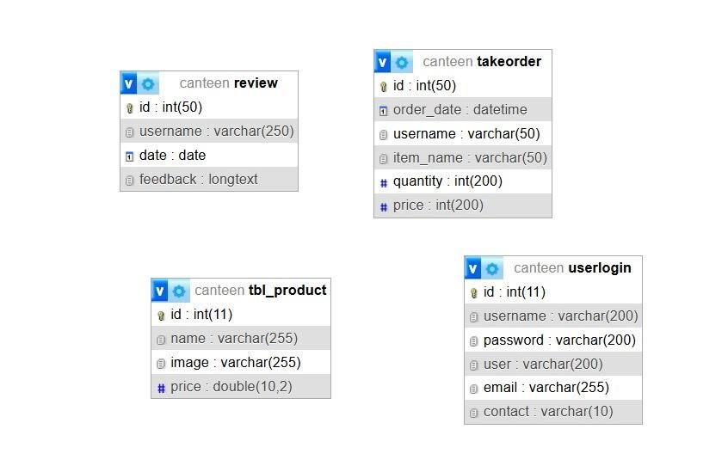

Figure 3. 7 Database Schema

### 3.2.3. Interface Design (UI Interface / Interface Structure Diagrams)

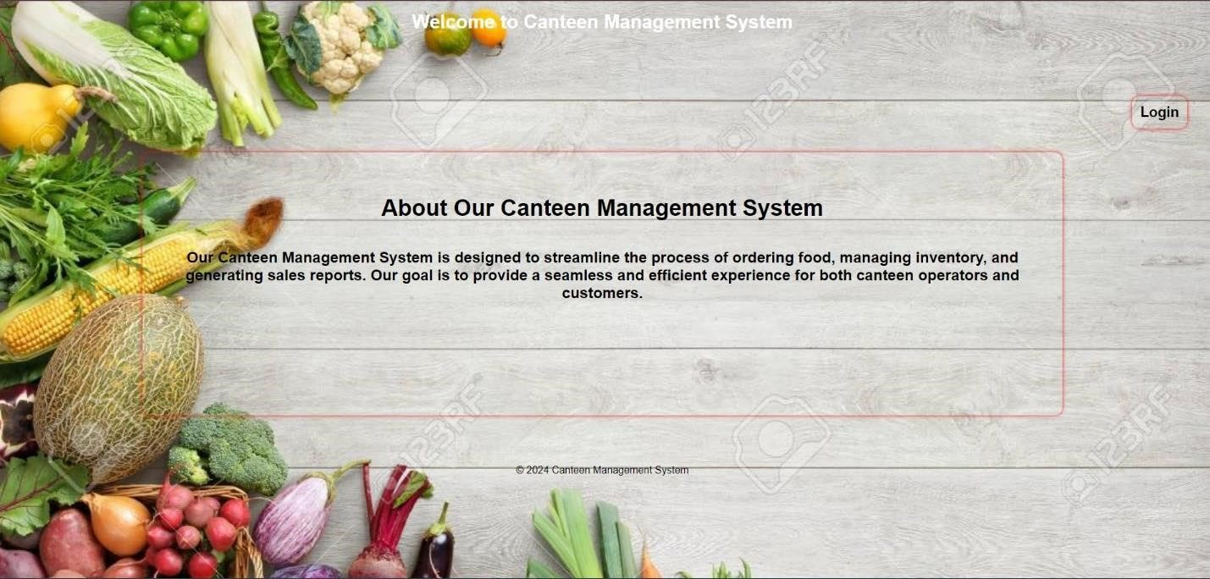

Figure 3. 8 Home-Page

# Chapter 4: Implementation and Testing

## 4.1. Implementation

There is various methodology in software development practices. Among them, waterfall mythology is implemented as the requirement desired by the organization is fixed and need not be changed in the future. Waterfall method is popular for development of IT projects In a Waterfall model, each phase must be completed before the next phase can begin and there is no overlapping in the phases. In “The Waterfall” approach, the whole process of software development is divided into separate phases. The outcome of one phase acts as the input for the next phase sequentially. This means that any phase in the development process begins only if the previous phase is complete.Basic workflow in waterfall methodology

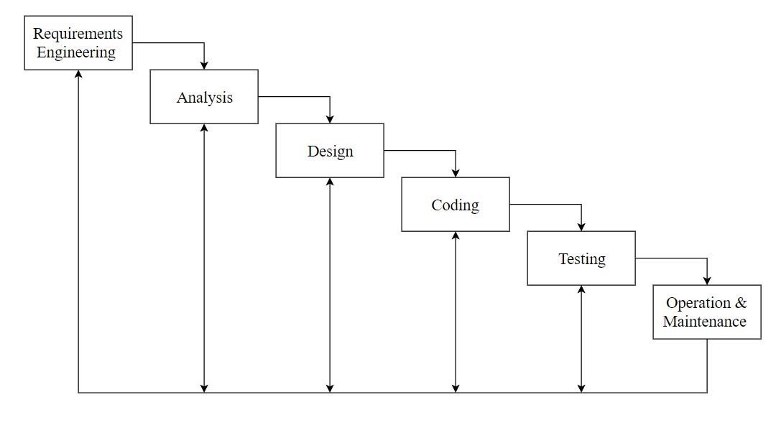

Figure 3. 9 Waterfall Model

* **Requirements:**

During this initial phase, the potential requirements of the system was analyzed which was written down in a specified document that served as the basis of all future development.

Studies about the various requirements of the system to be developed is done in this phase.

* **Analysis:**

During this phase, the system was analyzed in order to properly generate the system diagrams and model that will be used in the system development.

**Design:**

In this stage, all the diagram such as use-case, sequence diagram etc. has been designed in order to finalize the requirements of the system to be developed. During this phase, design specification was created that outlines how exactly the business logic covered in analysis will be technically implemented.

* **Coding:**

The actual source code is finally written in this stage of implementation, implementing all models, business logic, and service integrations that were specified in the prior stages. Different programming language such as HTML, CSS, PHP and JavaScript has been used to develop the system.

* **Testing:**

During this stage, the system has been tested to check if there is any error in the system. The system was also tested to check if it was as per the requirements defined by the café. Unit testing, integration testing and system testing was done to discover the bugs in the system if there are any.

* **Operations and Maintenance:**

At the final stage, the application was deployed to the live environment through which Student will be able to order food online. This stage entails not just the deployment of the system, but also subsequent support and maintenance that may be required to keep it functional and up-to-date.

### 4.1.1. Tools Used (CASE tools, Programming languages, Database platforms)

**Front End Tools HTML:**

HTML is used to describe the structure of Web pages

**CSS:**

CSS is used for describing the presentation of Web pages, including colors, layout, and fonts.

**Bootstrap:**

Bootstrap used to manage the content of website.

List:

bootstrap.css • bootstrap-theme.css

**JavaScript:**

JavaScript web framework is one of the best ways to stack backend and frontend frameworks.

List:

* bootstrap.js
* bootstrap.min.js
* jquery.js

## Back End Tool

**PHP:**

The PHP Hypertext Preprocessor (PHP) is a programming language used to create dynamic content that interacts with databases. It helps us to send and get request and data from and to databases like MySQL. PHP is basically used for developing webbased software applications. PHP can communicate with client-side languages like JavaScript and HTML.

It executes in server along with maximum all available web servers like Apache, IIS (Internet Information Server) etc.

**MYSQL:**

MySQL is an open-source relational database management system (RDBMS). We have used MySQL to store and retrieve data. The data in a MySQL database are stored in tables which consists of columns and rows.

**Elastic Email:**

Elastic Email is a fast and reliable email delivery service for sending marketing and transactional emails.

## 4.2 Implementation Details of Modules

There are different module descriptions. They are:

* Registration Module:

This module is dedicated to register all the complaints from the students whenever they come to compliant. The process of this module is divided into two sub processes in which one registers the complete details of the Student who wants to submit the compliant, other registers the complete details of the compliant

Monitoring Module

This module is dedicated to monitoring the complaints by searching the complaints and updating the status of complaints at any time. The process of this module is divided into two sub processes in which one searches for complaints and other updates the status.

* Reports Module:

Report generation module is dedicated to produce reports based on the information to given by the student. The process of this module is main divided into two sub processes in which one gives summary report other gives the detailed report

* Administration Module:

Administration module is dedicated to administrate the students, divisions, categories and sections etc

## 4.3 Testing

Testing is the process of detecting errors. It performs very critical role for quality assurance and for ensuring the reliability of software. The results of testing are used later on during maintenance also.

### 4.3.1. Test Cases for Unit Testing

Unit testing is a [software d](https://searchmicroservices.techtarget.com/definition/software)evelopment process in which the smallest testable parts of an [application a](https://searchsoftwarequality.techtarget.com/definition/application)re individually and independently scrutinized for proper operation (Rouse, Rouse, Margaret Rouse, & James Denman, n.d.). The main objective of unit testing is to isolate written code to test and determine if it works as intended. Unit testing is an important step in the development process, because it can help detect early flaws in code which may be more difficult to find in later testing stages.

Table 4. 1 Unit Testing

|  |  |  |  |  |
| --- | --- | --- | --- | --- |
| **S.**  **N** | **Test Cases** | **Input Data** | **Expected**  **Outcome** | **Result** |
| 1. | Login Page | Username: admin  Password: 1234 | Must be redirected to home page after successful login. | Succeeded |
| 2. | Login Page | Username and password empty | Both username and password field required. | Failed |
| 3. | Login Page | Username: admin  Password: admin12 | Invalid username and password, redirected to login page | Failed |
| 4. | Create account | Name: abc  Email:abc@gmail.com  Password:12345  Contact: 9818902480 | Login successfully | succeeded |
| 5. | Create account | Name: abc123  Email: abc@gmail.com  Password:12345  Contact: 9818902480 | Name entered is invalid | Failed |
| 6. | Create account | Name: abc  Email: abcgmail.com  Password:12345  Contact: 9818902480 | Email is invalid | Failed |
| 7 | Create account | Name: abc  Email: abc@gmail.com  Password:12345  Contact: 9818902480a | Contact is invalid | Failed |
| 8. | Add item | Name: Chana  Quantity: null | Quantity must be entered | Failed |
| 9. | Add item | Name: Chana  Quantity: 2 | Add item  successfully | succeeded |

### 4.2.2. Test Cases for System Testing

System Testing is the testing of a complete and fully integrated software product. Usually, software is only one element of a larger computer-based system. Ultimately, software is interfaced with other software/hardware systems. System Testing is actually a series of different tests whose sole purpose is to exercise the full computer-based system.

Table 4. 2 System Testing

|  |  |  |  |  |
| --- | --- | --- | --- | --- |
| **S. N** | **Test Cases** | **Input Data** | **Expected Outcome** | **Result** |
| 1. | Order food | Quantity: a | Invalid quantity | Failed |
| 2. | Order food | Quantity: 5 | Redirected to place order page | Succeeded |
| 3. | Confirm order | Class: null | Address required | Failed |
| 4. | Confirm order | Class: BCA | Confirm order  successful | Succeeded |

# Chapter 5: Conclusion and Future Recommendations

## 5.1 Lesson Learn / Outcome

Our project is concerned on providing a web application that can keep record of the Student, data entry into database and then maintaining those data, keeping a track of the billing. As this project is completed, it allows student to sign up or login, display the menu and order the food. This system can also be use in Restaurants, Cafeteria, etc. The system is acceptable as well as reliable. The results obtained through the developed system shows that it can be used to automate the existing canteen management system.

## 5.2 Conclusion

* Helpful to perform work and manage data
* Provide easy, accurate, unambiguous and faster data access

## 5.3 Future Recommendations

It is worth mentioning that this project work is open for further enhancement, with the expectation that it becomes more robust and better enhanced. There are still lots of areas that can be improved further regarding our website as follows:

* Fully functional reservation platform so that payment can be done through online transaction.
* The website can be access by multiple college so that single website could be used.

**References:**

1. A. Author, B. Author, and C. Author, "Title of the Ordering System Paper," Journal of System Research, vol. 10, no. 1, pp. 23-34, 2020.
2. D. Author and E. Author, "Menu Automation: Real-Time Menu Generation,"

International Journal of Food Service Technology, vol. 15, no. 4, pp. 56-67, 2019.

1. F. Author, G. Author, and H. Author, "Order Automation and Student Decision Making," Journal of Automated Systems, vol. 12, no. 2, pp. 89-101, 2021.
2. F. Davis, R. Bagozzi, and P. Warshaw, "User Acceptance of Computer Technology: A Comparison of Two Theoretical Models," Management Science, vol. 35, no. 8, pp. 9821003, 1989.
3. I. Author, J. Author, and K. Author, "Android-Based Ordering System with Cash on Delivery," International Journal of Mobile Computing, vol. 8, no. 3, pp. 45-59, 2018.
4. J. Smith, L. Johnson, and E. Brown, "Challenges in Implementing Canteen

Management Systems," Journal of Food Service Management, vol. 10, no. 4, pp. 66-73, 2018.

1. L. Author, M. Author, and N. Author, "RFID Radio-Controlled Ordering System," Journal of Innovative Hardware Systems, vol. 7, no. 1, pp. 12-24, 2017.
2. M. Jones, T. Smith, and R. Williams, "Impact of Automated Food Ordering Systems on Customer Satisfaction," Journal of Food Service Technology, vol. 12, no. 3, pp. 45-58, 2019. [9] O. Author, P. Author, and Q. Author, "Smart Canteen: Registration-Based Ordering," International Journal of Smart Technology, vol. 11, no. 4, pp. 78-89, 2019.
3. R. Author, S. Author, and T. Author, "Online Menu Ordering on an Outdated Framework," Journal of Legacy Systems, vol. 9, no. 2, pp. 33-47, 2016.
4. S. Thompson and P. Martinez, "Ensuring Data Security in Online Food Ordering Systems," Journal of Information Security, vol. 15, no. 2, pp. 101-115, 2020.